** **

**FABRICATION OF COMPACT GRASS TRIMMER USING CAM AND FOLLOWER**

**A PROJECT REPORT**

***Submitted by***

**LALITHRAJ.R (927622BME044)**

**LENALISSANTH.N.B (927622BME045)**

**MANOJ.A (927622BME309)**

***in partial fulfillment for the award of the degree***

***of***

**BACHELOR OF ENGINEERING**

**IN**

MECHANICAL ENGINEERING

**M.KUMARASAMY COLLEGE OF ENGINEERING, KARUR**

ANNA UNIVERSITY: CHENNAI 600 025

**APRIL 2024**

M.KUMARASAMY COLLEGE OF ENGINEERING, KARUR

**BONAFIDE CERTIFICATE**

Certified that this project report **“FABRICATION OF COMPACT GRASS TRIMMER USING CAM AND FOLLOWER”** is the bonafide work of **“ LALITHRAJ.R (927622BME044) , LENALISSANTH.N.B (927622BME045) , MANOJ.A (927622BME309)”** who carried out the project work during the academic year 2023 – 2024 under my supervision. Certified further, that to the best of my knowledge the work reported herein does not form part of any other project report or dissertation on the basis of which a degree or award was conferred on an earlier occasion on this or any other candidate.

|  |  |
| --- | --- |
| **SIGNATURE** | **SIGNATURE** |
| Dr. M. LOGANATHAN..,ME..,Phd.., | Dr. S. PADMAVATHY, M.E.,MBA.., Ph.D.., |
| **HEAD OF THE DEPARTMENT** | **SUPERVISOR** |
| Department of Mechanical Engineering, | Department of Mechanical Engineering, |
| M.Kumarasamy College of Engineering, | M.Kumarasamy College of Engineering, |
| Thalavapalayam, Karur-639113. | Thalavapalayam, Karur-639113. |

This project report has been submitted for the end semester project viva voce Examination held on

INTERNAL EXAMINER EXTERNAL EXAMINER

### DECLARATION

We affirm that the Project titled **“FABRICATION OF COMPACT GRASS TRIMMER USING CAM AND FOLLOWER”** being submitted in partial fulfillment of for the award of Bachelor of Engineering in Mechanical Engineering, is the original work carried out by us. It has not formed the part of any other project or dissertation on the basis of which a degree or award was conferred on an earlier occasion on this or any other candidate.

Student name Signature

### LALITHRAJ. R ----------------------

1. LENALISSANTH. N.B ----------------------
2. MANOJ. A ----------------------

Name and signature of the supervisor with date

Dr.S.Padmavathy,ME..,MBA..,Phd..,

ACKNOWLEDGEMENT

Our sincere thanks to Thiru. M. Kumarasamy, Founder and Dr. K. Ramakrishnan, B.E, Chairman of M. Kumarasamy College of Engineering for providing extra ordinary infrastructure, which helped us to complete the project in time.

It is a great privilege for us to express our gratitude to our esteemed Principal Dr.B.S.Murugan M.E., Ph.D. for providing us right ambiance for carrying out the project work.

We would like to thank Dr.M.Loganathan M.E., Ph.D, Head, Department of Mechanical Engineering, for their unwavering moral support throughout the evolution of the project.

We offer our whole hearted thanks to our internal guide Dr. S. Padmavathy, M.E., MBA, Ph.D. Associate Professor, Department of Mechanical Engineering, for her/his constant encouragement, kind co-operation, valuable suggestions and support rendered in making our project a success.

We offer our whole hearted thanks to our project coordinator Dr.H. Vinoth Kumar M.E., Ph.D., Department of Mechanical Engineering, for his constant encouragement, kind co-operation, valuable suggestions and support rendered in making our project a success.

We glad to thank all the Teaching and Non-Teaching Faculty Members of Department of Mechanical Engineering for extending a warm helping hand and valuable suggestions throughout the project.

Words are boundless to thank Our Parents and Friends for their constant encouragement to complete this project successfully.

# **INSTITUTION VISION & MISSION**

## **Vision**

* To emerge as a leader among the top institutions in the field of technical education.

## **Mission**

* Produce smart technocrats with empirical knowledge who can surmount the global challenges.
* Create a diverse, fully-engaged, learner-centric campus environment to provide quality education to the students.
* Maintain mutually beneficial partnerships with our alumni, industry and professional associations.

# **DEPARTMENT VISION, MISSION, PEO, PO & PSO**

## **Vision**

* To create globally recognized competent Mechanical engineers to work in multicultural environment.

## **Mission**

* To impart quality education in the field of mechanical engineering and to enhance their skills, to pursue careers or enter into higher education in their area of interest.
* To establish a learner-centric atmosphere along with state-of-the-art research facility.
* To make collaboration with industries, distinguished research institution and to become a centre of excellence.

# **PROGRAM EDUCATIONAL OBJECTIVES (PEOS)**

The graduates of Mechanical Engineering will be able to

* PEO1: Graduates of the program will accommodate insightful information of engineering principles necessary for the applications of engineering.
* PEO2: Graduates of the program will acquire knowledge of recent trends in technology and solve problem in industry.
* PEO3: Graduates of the program will have practical experience and interpersonal skills to work both in local and international environments.
* PEO4: Graduates of the program will possess creative professionalism, understand their ethical responsibility and committed towards society.

# 

The following are the Program Outcomes of Engineering Graduates:Engineering Graduates will be able to:

# **PROGRAM OUTCOMES**

1. **Engineering knowledge:** Apply the knowledge of mathematics, science, engineering fundamentals, and an engineering specialization to the solution of complex engineering problems.
2. **Problem analysis:** Identify, formulate, review research literature, and analyze complex engineering problems reaching substantiated conclusions using first principles of mathematics, natural sciences, and engineering sciences.
3. **Design/development of solutions:** Design solutions for complex engineering problems and design system components or processes that meet the specified needs with appropriate consideration for the public health and safety, and the cultural, societal, and environmental considerations.
4. **Conduct investigations of complex problems:** Use research-based knowledge and research methods including design of experiments, analysis and interpretation of data, and synthesis of the information to provide valid conclusions.
5. **Modern tool usage:** Create, select, and apply appropriate techniques, resources, and modern engineering and IT tools including prediction and modeling to complex engineering activities with an understanding of the limitations.
6. **The engineer and society:** Apply reasoning informed by the contextual knowledge to assess societal, health, safety, legal and cultural issues and the consequent responsibilities relevant to the professional engineering practice.
7. **Environment and sustainability:** Understand the impact of the professional engineering solutions in societal and environmental contexts, and demonstrate the knowledge of, and need for sustainable development.
8. **Ethics:** Apply ethical principles and commit to professional ethics and responsibilities and norms of the engineering practice.
9. **Individual and team work:** Function effectively as an individual, and as a member or leader in diverse teams, and in multidisciplinary settings.
10. **Communication:** Communicate effectively on complex engineering activities with the engineering community and with society at large, such as, being able to comprehend and write effective reports and design documentation, make effective presentations, and give and receive clear instructions.
11. **Project management and finance:** Demonstrate knowledge and understanding of the engineering and management principles and apply these to one’s own work, as a member and leader in a team, to manage projects and in multidisciplinary environments.
12. **Life-long learning:** Recognize the need for, and have the preparation and ability to engage in independentand life-long learning in the broadest context of technological change.

**PROGRAM SPECIFIC OUTCOMES (PSOs)**

**The following are the Program Specific Outcomes of Engineering Graduates:** The students will demonstrate the abilities

* 1. **Real world application:** To comprehend, analyze, design and develop innovative products and provide solutions for the real-life problems.
  2. **Multi-disciplinary areas:** To work collaboratively on multi-disciplinary areas and make quality projects.

|  |  |  |
| --- | --- | --- |
| **Course Outcomes** | At the end of this course, learners will be able to: | **Knowledge Level** |
| CO-1 | Identify the issues and challenges related to industry, society and environment. | Apply |
| CO-2 | Describe the identified problem and formulate the possible solutions | Apply |
| CO-3 | Design / Fabricate new experimental set up/devices to provide solutions for  the identified problems | Analyse |
| CO-4 | Prepare a detailed report describing the project outcome | Apply |
| CO-5 | Communicate outcome of the project and defend by making an effective oral presentation. | Apply |

**Research oriented innovative ideas and methods:** To adopt modern tools, mathematical, scientific and engineering fundamentals required to solve industrial and societal problems.

**MAPPING OF PO & PSO WITH THE PROJECT OUTCOME**

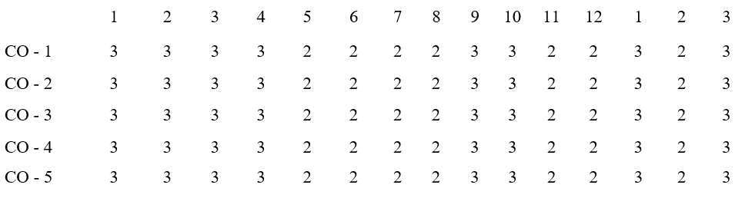

**Program**

**Course**

**Outcomes**

**ProgramOutcomes**

**Specific outcome**

**Outcomes**

|  |  |  |
| --- | --- | --- |
|  | **CONTENT** |  |
| **CHAPTER .NO** | **TITLE** | **PAGE.NO** |
|  | ABSTRACT | 3 |
| 1 | INTRODUCTION | 4 |
| 2 | MAJOR COMPONENTS | 5 |
|  | 2.1 DC MOTOR | 6 |
|  | 2.2 BATTERY | 8 |
|  | 2.3 SHAFT | 9 |
|  | 2.4 BLADE | 10 |
|  | 2.5 CAM AND FOLLOWER | 11 |
|  | 2.6 METAL FRAME | 13 |
| 3 | DESIGN | 14 |
|  | 3.1 AUTO-CAM &FEATURES | 14 |
|  | 3.2 2D LAYOUT MODEL DIAGRAM | 15 |
| 4 | MANUFACTURING PROCESS | 16 |
|  | 4.1 WORKING MODEL | 20 |
| 5 | WORKING PRINCIPLE | 22 |
| 6 | ADVANTAGE & APPLICATION | 23 |
| 7 | CONCLUSION & | 24 |
| 8 | REFERENCE | 25 |

**ABSTRACT**

A compact grass trimmer employs a reciprocating mechanism powered by a Cam and follower,DC motor, battery, and a cutting disc. The DC motor, linked to the battery, generates rotational motion, transferred to the cutting disc through a reciprocating mechanism. This mechanism translates the rotary motion into back-and-forth movements, enabling precise trimming.

The battery serves as the power source, offering portability and eliminating the need for a direct power connection. Its capacity determines the trimmer's runtime. The cutting disc, designed with sharp edges, efficiently cuts grass and weeds upon contact.

This compact design enhances maneuverability in tight spaces, allowing users to access areas typically challenging to reach with conventional trimmers. The reciprocating mechanism provides controlled and efficient cutting while minimizing power consumption, making the trimmer suitable for small-scale landscaping and maintenance tasks. Its lightweight nature and ease of use make it an ideal choice for both professionals and DIY enthusiasts seeking a versatile grass trimming solution.

**CHAPTER 1**

**INTRODUCTION**

Introducing a revolutionary approach to lawn care, the compact grass trimmer redefines precision and portability in landscaping tools. This innovative device integrates a reciprocating mechanism powered by a DC motor, battery, and cutting disc to deliver efficient grass trimming in a compact and versatile package.

At its core, this trimmer leverages a DC motor, a reliable and efficient source of rotational power. Linked to a rechargeable battery, this motor ensures cordless operation, granting users freedom of movement without compromising on performance. The reciprocating mechanism, a hallmark of this trimmer's design, ingeniously converts rotary motion into precise back-and-forth movements. This mechanism is directly connected to a cutting disc, featuring sharp edges tailored for grass and weed trimming.

The synergy of these components produces a trimmer that excels in maneuverability and efficiency. Its compact size allows access to confined areas while maintaining the power needed for effective trimming. The absence of cords eliminates tangling and offers unrestricted movement around the yard or garden.

This tool's versatility and user-friendly design cater to both professional landscapers and homeowners seeking a hassle-free solution for maintaining their outdoor spaces.

With its lightweight construction, ease of operation, and eco-friendly battery system, this compact grass trimmer sets a new standard for precision and convenience in lawn care equipment.

**CHAPTER 2**

**MAJOR COMPONENTS**

1. DC MOTOR
2. BATTERY
3. SHAFT
4. BLADE
5. CAM AND FOLLOWER
6. MATEL FRAME
7. COST ESTIMATION

**2.1 DC MOTOR**

A DC motor is any of a class of rotary electrical machines that converts direct current electrical energy into mechanical energy. The most common types rely on theforces produced by magnetic fields. Nearly all types of DC motors have some internal mechanism, either electromechanical or electronic; to periodically change the direction of current flow in part of the motor. Different number of stator and armature fields as well as how they are connected provides different inherent speed/torque regulation characteristics. The speed of a DC motor can be controlled by changing the voltage applied to the armature. The introduction of variable resistance in the armature circuit or field circuit allowed speed control. Modern DC motors are often controlled by power electronics systems which adjust the voltage by "chopping" the DC current into on and off cycles which have an effective lower voltage.

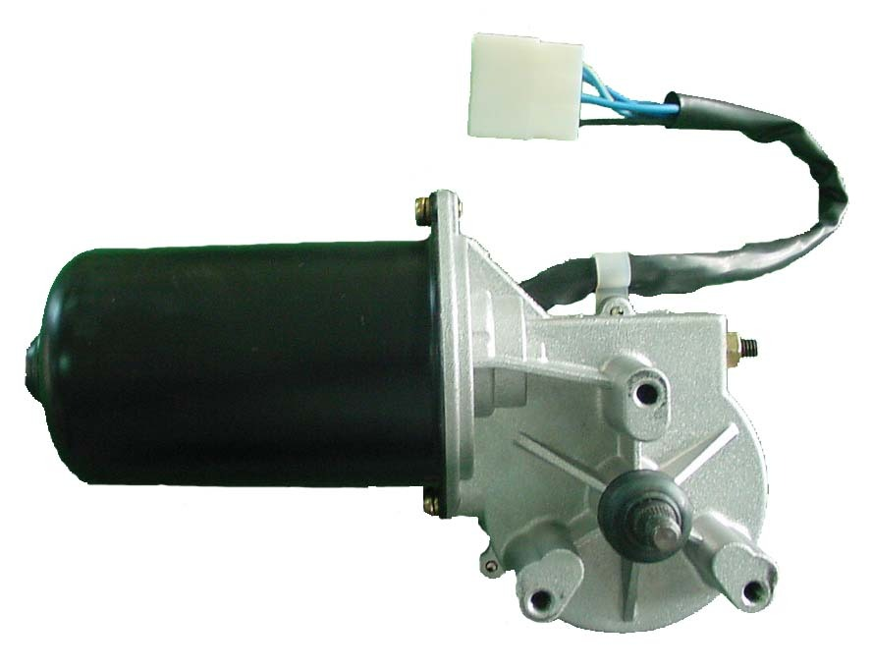

Fig 2.1 DC motor

In any electric motor, operation is based on simple electromagnetism. A current-carrying conductor generates a magnetic field; when this is then placed in an external magnetic field, it will experience a force proportional to the current in the conductor, and to the strength of the external magnetic field. As you are well aware of from playing with magnets as a kid, opposite (North and South) polarities attract, while like polarities (North and North, South and South) repel. The internal configuration of a DC motor is designed to harness the magnetic interaction between a current-carrying conductor and an external magnetic field to generate rotational motion.

Specification of a DC motor Speed : N = 30 RPM

Voltage : V = 12 Volt

Loading Current : I = 300 MA No Load Current : I = 60 Ma

Power : P = VxI=12x0.3 = 3.6WATT

P = 0.0048HP

Motor Efficiency : E = 36%

Motor Shaft Diameter : D = 6 mm

**2.2** **BATTERY**

A battery is a device that converts chemical energy directly to electrical energy. It consists of a number of voltaic cells; each voltaic cell consists of two half cells connected in series by a conductive electrolyte containing anions and cations. One halfcell includes electrolyte and the electrode to which anions migrate, i.e., the anode or negative electrode; the other half-cell includes electrolyte and the electrode to which cations migrate, i.e., the cathode or positive electrode. In the redox reaction that powers the battery, reduction occurs to cations at the cathode, while oxidation occurs to anions at the anode. The electrodes do not touch each other but they are electrically connected by the electrolyte. Some cells use two half-cells with different electrolytes. A separator between half cells allows ions to flow, but prevents mixing of the electrolytes. Each half cell has an electromotive force determined by its ability to drive electric current from the interior to the exterior of the cell. The net EMF of the cell is the difference between the EMF of its half-cells, as first recognized by Volta. Therefore, if the electrodes have EMF and, then the net EMF is in other words, the net EMF is the difference between the reduction potentials of the half-reactions.

. 

Fig 2.2 Battery

**2.3 SHAFT**

Shaft is a common and important machine element. It is a rotating member, in general, has a circular cross-section and is used to transmit power. The shaft may be hollow or solid. The shaft is supported on bearings and it rotates a set of gears or pulleys for the purpose of power transmission. The shaft is generally acted upon by bending moment, torsion and axial force. Design of shaft primarily involves in determining stresses at critical point in the shaft that is arising due to aforementioned loading. Other two similar forms of a shaft are axle and spindle. Axle is a non-rotating member used for supporting rotating wheels etc. and do not transmit any torque. Spindle is simply defined as a short shaft.

**Specifications**

Shaft diameter: 12mm

Material: mild steel

Length:26 inch

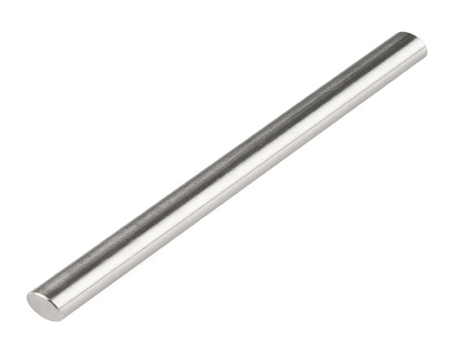

Fig 2.3 Shaft

**2.4** **BLADE**

**Sharpening** is the process of creating or refining a sharp edge of appropriate shape on a tool or implement designed for cutting. Sharpening is done by grinding away material on the implement with an [abrasive](https://en.wikipedia.org/wiki/Abrasive) substance harder than the material of the implement, followed sometimes by processes to polish the sharp surface to increase smoothness and to correct small mechanical deformations without regrinding.ery sharp knives sharpen at about 10 dps (degrees per side) (which implies that the knife's edge has an included angle of 20-degrees).

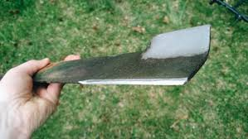

Fig 2.4 Blade

**2.5 CAM AND FOLLOWER**

A cam and follower mechanism is a mechanical device that converts rotary motion into reciprocating or oscillating motion. It consists of three main components:

1. The cam - a rotating element with an irregular shape that imparts motion to the follower

2. The follower - a sliding or rolling element that follows the contour of the cam

3. The frame - holds the cam and follower and guides the follower's motion

As the cam rotates, its varying cross-section causes the follower to reciprocate or oscillate. The cam's shape dictates the motion of the follower, allowing for precise control and coordination in various applications.

Cam and follower mechanisms are widely used in internal combustion engines to operate the valves, as well as in automatic machinery, textile machines, clocks, and pumps. They enable the conversion of rotary motion into linear motion for another component.

The cam and follower make direct contact, with the follower maintained in contact by springs or gravity.

Different cam and follower profiles allow for various follower motions like uniform velocity, simple harmonic motion, and cycloidal motion.

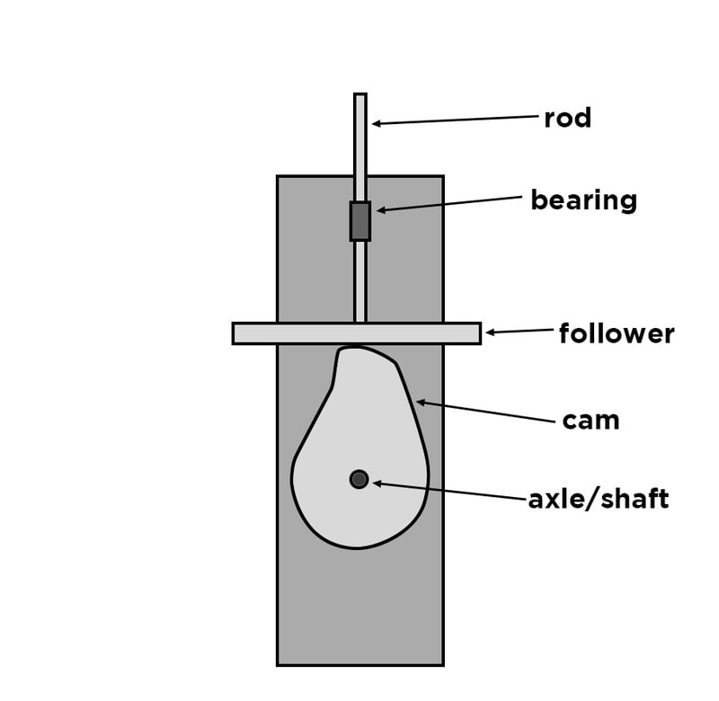

Fig 2.5 Cam and Follower

**2.6 METAL FRAME**

The metal frame is generally made of **mild steel** bars for machining, suitable for lightly stressed components including studs, bolts, gears and shafts. It can be case-hardened to improve wear resistance. They are available in bright rounds, squares and flats, and hot rolled rounds

Suitable machining allowances should therefore be added when ordering. It does not contain any additions for enhancing mechanical or machining properties. Bright drawn mild steel is an improved quality material, free of scale, and has been cold worked (drawn or rolled) to size. It is produced to close dimensional tolerances. Straightness and flatness are better than black steel. It is more suitable for repetition precision machining. Bright drawn steel has more consistent hardness, and increased tensile strength. Bright steel can also be obtained in precision turned or ground form if desired.

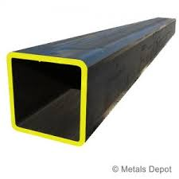

Fig 2.6 Metal frame

**CHAPTER 3**

**DESIGN**

**3.1 AUTO-CAD**

AutoCAD is a 2D and 3D computer-aided design (CAD) software application developed by Autodesk. It was first released in December 1982 for the CP/M and IBM PC platforms as a desktop app running on microcomputers with internal graphics controllers. Initially a DOS application, subsequent versions were later released for other platforms including Classic Mac OS (1989), Microsoft Windows (1993) and macOS (2010), along with companion web and mobile applications.

AutoCAD is a general drafting and design application used in industry by architects, project managers, engineers, graphic designers, city planners and other professionals to prepare technical drawings. After discontinuing the sale of perpetual licenses in January 2016, commercial versions of AutoCAD are licensed through a term-based subscription.

**FEATURES**

ESRI ArcMap 10 permits export as AutoCAD drawing files. Civil 3D permits export as AutoCAD objects and as LandXML. Third-party file converters exist for specific formats such as Bentley MX GENIO Extension, PISTE Extension (France), ISYBAU (Germany), OKSTRA and Microdrainage (UK);also, conversion of .pdf files is feasible, however, the accuracy of the results may be unpredictable or distorted. For example, jagged edges may appear. Several vendors provide online conversions for free such as Cometdocs.

AutoCAD and AutoCAD LT are available for English, German, French, Italian, Spanish, Japanese, Korean, Chinese Simplified, Chinese Traditional, Brazilian Portuguese, Russian, Czech, Polish and Hungarian (also through additional language packs). The extent of localization varies from full translation of the product to documentation only. The AutoCAD command set is localized as a part of the software localization.

AutoCAD supports a number of APIs for customization and automation. These include AutoLISP, Visual LISP, VBA, .NET and ObjectARX. ObjectARX is a C++ class library, which was also the base for: products extending AutoCAD functionality to specific fieldscreating products such as AutoCAD Architecture, AutoCAD Electrical, AutoCAD Civil 3Dthird-party AutoCAD-based application.

There are a large number of AutoCAD plugins (add-on applications) available on the application store Autodesk Exchange Apps. AutoCAD's DXF, drawing exchange format, allows importing and exporting drawing information.

**3.2 2D LAYOUTS OF MODEL**

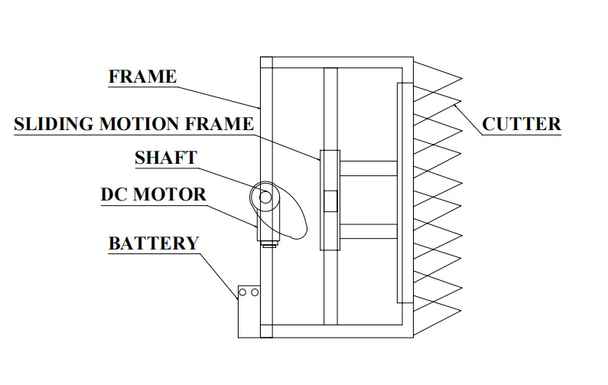

Fig 3.1

**CHAPTER 4**

**MANUFACTURING PROCESS**

Manufacturing processes are the steps through which raw materials are transformed into a final product. The manufacturing process begins with the creation of the materials from which the design is made. These materials are then modified through manufacturing processes to become the required part. Manufacturing processes can include treating (such as heat treating or coating), machining, or reshaping the material. The manufacturing process also includes tests and checks for quality assurance during or after the manufacturing, and planning the production process prior to manufacturing.

**SAWING:**

Cold saws are saws that make use of a circular saw blade to cut through various types of metal, including sheet metal. The name of the saw has to do with the action that takes place during the cutting process, which manages to keep both the metal and the blade from becoming too hot. A cold saw is powered with electricity and is usually a stationary type of saw machine rather than a portable type of saw.

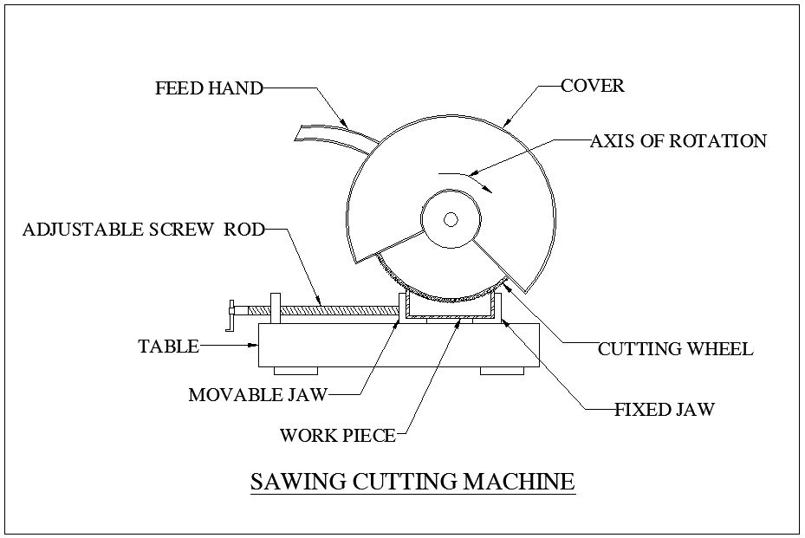

Fig 4.1

The circular saw blades used with a cold saw are often constructed of high speed steel. Steel blades of this type are resistant to wear even under daily usage. The end result is that it is possible to complete a number of cutting projects before there is a need to replace the blade.High speed steel blades are especially useful when the saws are used for cutting through thicker sections of metal.

**WELDING:**

Welding is a process for joining similar metals. Welding joins metals by melting and fusing **1,** the base metals being joined and **2,** the filler metal applied. Welding employs pinpointed, localized heat input. Most welding involves ferrous-based metals such as steel and stainless steel.Weld joints are usually stronger than or as strong as the base metals being joined.

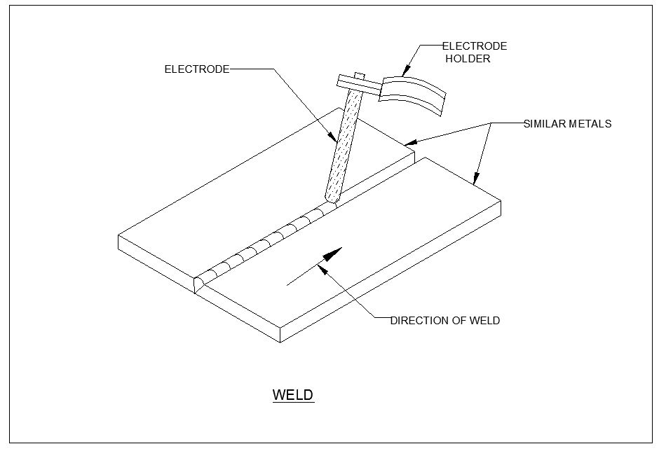

Fig 4.2

Welding is used for making permanent joints. It is used in the manufacture of automobile bodies, aircraft frames, railway wagons, machine frames, structural works, tanks, furniture, boilers, general repair work and ship building.

**OPERATION:**

Several welding processes are based on heating with an electric arc, only a few are considered here, starting with the oldest, simple arc welding, also known as shielded metal arc welding (SMAW) or stick welding.

In this process an electrical machine (which may be DC or AC, but nowadays is usually AC) supplies current to an electrode holder which carries an electrode which is normally coated with a mixture of chemicals or flux. An earth cable connects the work piece to the welding machine to provide a return path for the current. The weld is initiated by tapping ('striking') the tip of the electrode against the work piece which initiates an electric arc. The high temperature generated (about 6000oC) almost instantly produces a molten pool and the end of the electrode continuously melts into this pool and forms the joint.

The operator needs to control the gap between the electrode tip and the work piece while moving the electrode along the joint.

**DRILLNG:**

Drilling is a cutting process that uses a drill bit to cut or enlarge a hole of circular cross-section in solid materials. The drill bit is a rotary cutting tool, often multipoint. The bit is pressed against the work piece and rotated at rates from hundreds to thousands of revolutions per minute. This forces the cutting edge against the work piece, cutting off chips (sward) from the hole as it is drille

**4.1 WORKING MODEL**

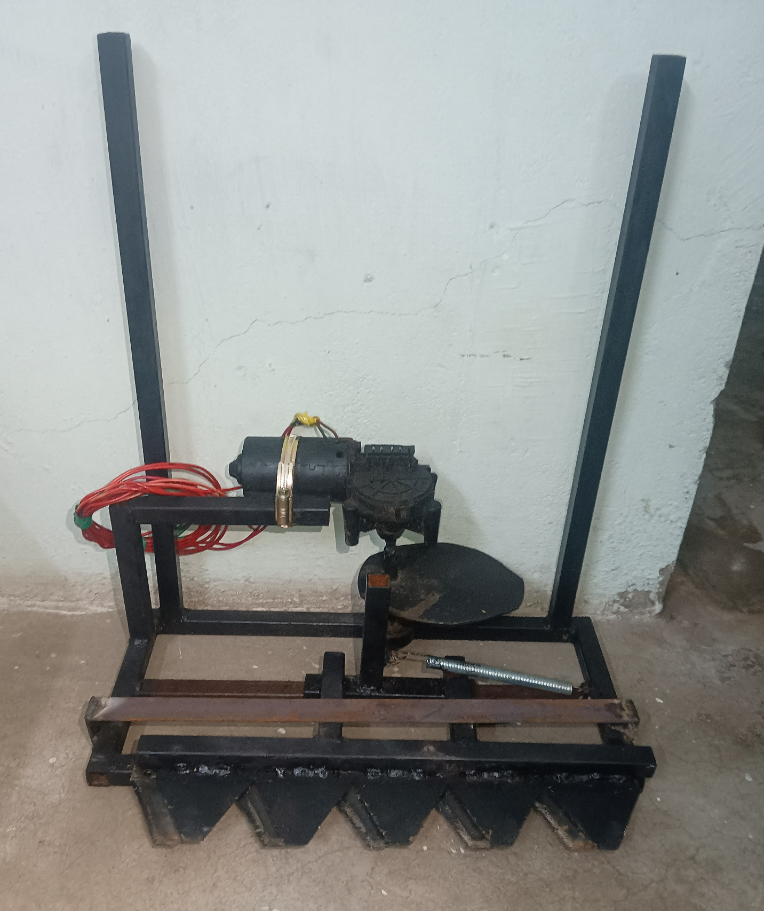

Fig 4.2

**COST ESTIMATION**

|  |  |  |
| --- | --- | --- |
| **SL.NO** | **DISCRIPTION** | **COST Rs:** |
| 1 | DC MOTOR | 1000 |
| 2 | BATTERY | 1000 |
| 3 | BEARING | 100 |
| 4 | FRAME | 1200 |
| 5 | SHAFT | 300 |
| 6 | METAL STRIP | 200 |
| 7 | BLADE | 700 |
| 8 | DISC | 500 |
| 9 | TOTAL | 5000 |

**CHAPTER 5**

**WORKING PRINCIPLE**

The compact grass trimmer operates through a DC motor powered by a rechargeable battery, connected to a cutting disc via a reciprocating mechanism. The battery supplies electricity to the DC motor, generating rotational motion. This rotation is translated into back-and-forth movements by the reciprocating mechanism, converting the continuous rotation into linear motion. The cutting disc, affixed to this mechanism, moves rapidly in a reciprocating manner, allowing its sharp edges to trim grass and weeds upon contact. This synchronized process enables efficient grass cutting. The DC motor's power, combined with the reciprocating mechanism's precision, grants the trimmer its ability to navigate tight spaces while effectively trimming vegetation. Cordless operation and the lightweight design make this trimmer user-friendly for both professional landscapers and homeowners seeking a versatile and efficient lawn care solution.

**CHAPTER 6**

**ADVANTAGES**

The compact grass trimmer, employing a reciprocating mechanism with a DC motor, battery, and cutting disc, offers several advantages. Firstly, its cordless design, powered by a rechargeable battery, ensures unrestricted movement and eliminates the hassle of cords, enhancing maneuverability. The reciprocating mechanism enables precise trimming, allowing access to tight spaces where conventional trimmers struggle.

Additionally, the lightweight construction enhances user comfort during prolonged use and facilitates easy handling, reducing fatigue. The efficient use of the DC motor and the reciprocating mechanism optimizes power consumption, extending battery life for longer trimming sessions. Furthermore, the trimmer's versatility suits various landscaping tasks, providing reliable performance for both professionals and DIY enthusiasts.

Its compact size and agile nature make it ideal for smaller areas or detailed work. Overall, this trimmer amalgamates convenience, precision, and portability, presenting a practical solution for maintaining lawns and gardens with efficiency and ease.

**APPLICATION**

* Professional Landscaping
* Residential Use
* Garden Maintenance
* Park Maintenance
* Sports Fields
* Farms and Orchards

**CHAPTER 7**

**CONCLUSION**

The existing model presents an Integrating feature of all the hardware components used have been developed in it. The mechanical cutter system helps to the agriculture products cutting and also used to decrease human assistance. The presence of each and every module has been reasoned out and placed very carefully. Hence the contributing to the best working unit for “Design and development of mechanical cutter” has been designed and fabricated perfectly. Thus, the work has been successfully fabricated and tested.

**REFERENCE**

1. N. Nagarajan, N.S. Siva Kumar and R. Savanna “Design and Fabrication of Lawn Mower” in Asian Journal of Applied Science and Technology, Volume 1, Issue4,Pages50- 54,May2017 <http://ajast.net/data/uploads/4ajast-13.pdf>.
2. Bidgar Pravin Dilip, Nikhil Bapu Pagar, Vickey S. Ugale, Sandip Wani,Sharmila“Design and Implementation of Automatic Solar Grass Cutter” in International Journal of Advanced Research in Electrical, Electronics and Instrumentation Engineering, Vol.6, Issue4, April2017, [http://www.ijareeie.com/upload/2017/april/37 _Design.pdf](http://www.ijareeie.com/upload/2017/april/37%20_Design.pdf)
3. G.Manoj Kumar, G. Sravanthi, J. Ankamma Chowdary, D. Aparna, V. Ajay Kumar “Solar Grass Cutter Robot with Obstacle Avoidance” in International Journal of Engineering Science and Computing Volume 7, Issue No.4, http://ijesc.org/upload/80f06c7ba794e5eea579 464954c9758d.Solar%20Grass%20Cutter%20 Robot%20with%20Obstacle%20Avoidance.p df
4. Mahesh Pande, Pratik Kuduse, Milind Pethkar, Lukesh Manusmare “Design and Fabrication of Grass Cutter” in International Journal for Research in Applied Science & Engineering Technology (IJRASET), Volume 6 Issue I, January2018 <https://www.ijraset.com/fileserve.php> ?FID=1 3104 Hajrachoudhury S.K., Hajrachoudhury, A.K. Nirjharroy, Elements of workshop technology volume II –twelfth edition Media promoters and publishers pvt .Ltd, 2007.
5. Rattan .S.S Theory of machines third edition. Tata McGraw Hill publications,New Delhi ,1988.
6. Ko Ying Hao, Zaidi Mohd Ripin “Nodal control of grass trimmer handel vibration” in International Journal of Industrial Ergonomics, volume 43,issue 1,January 2013 page 18-30, <https://doi.org/10.1016/j.ergon.2012.10.007>
7. Zulquernain Mallick “Optimization of operating parameters for a back-pack type grass trimmer” in International Journal of Industrial Ergonomics Volume 38, Issue 1, January 2008, Pages 101-110, <https://doi.org/10.1016/j.ergon.2007.09.005>
8. Hasan BAŞ, Yunus Emre KARABACAK “Triboinformatic modeling of the friction force and friction coefficient in a cam-follower contact using machine learning algorithms” in Tribology International Volume 181,March 2023,108336 <https://doi.org/10.1016/j.triboint.2023.108336>
9. Mishra, Diptanu Bhowmik “A brief description designing, modelling, and materials of cam-follower mechanism” in Materials Today: Proceedings Volume 44, Part 1, 2021, Pages 434-436 <https://doi.org/10.1016/j.matpr.2020.09.753>